**Inspiration:** Action Platform type games, Medieval era

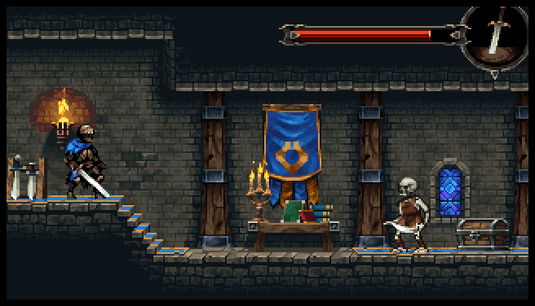 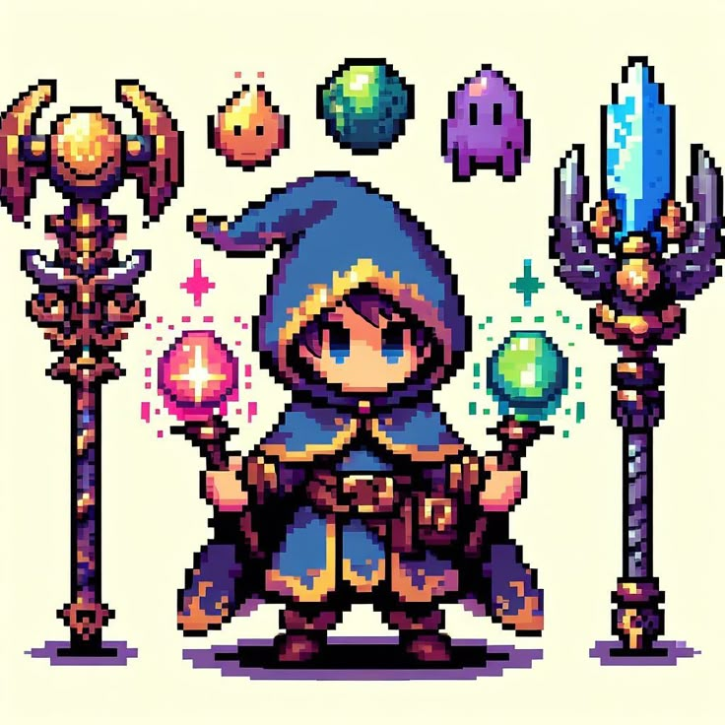 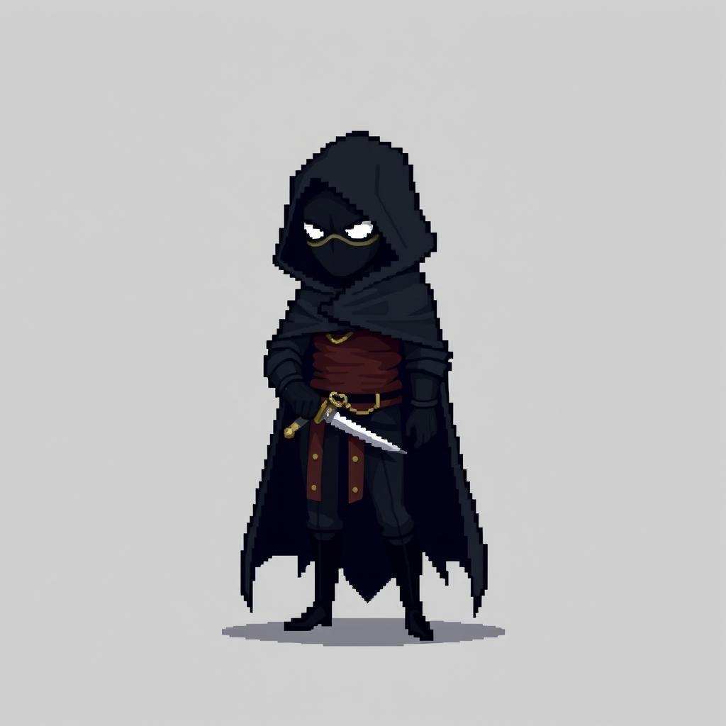

Medieval setting, pixel art, young mage, rogue mage

**Game description:**

In The Wandering Mage, the player plays as a young wizard who should retrieve the stolen crown that belonged to the king. The thief was some unknown rogue mage that spread magical traps and dark creatures all over the kingdom, corrupting the land and sealing pathways with spells or barriers.

The player starts with a bow and arrow using precision shots to attack enemies and interact with objects. As they progress, they unlock new magical abilities hidden in ancient spell books allowing them to reach previously unreachable areas, solve puzzles, and defeat tougher enemies.

The goal is to collect pieces of a fragmented map which will ultimately reveal the rogue mage’s hidden fortress within the king’s castle. Only by mastering both archery and magic can they confront the rogue mage in a final, climactic battle and reclaim the lost crown.

This 2D platformer is designed to be simple to play but engaging, with a mix of jumping, combat, and light puzzle-solving using elemental magic abilities unlocked throughout the journey.

**Genre:** 2D Action-Platformer

**Differentiating features:**

* Unlike most medieval platformers where players only use swords, this game blends ranged combat (bow & arrow) with elemental spells.
* Players must use spells creatively (e.g., freezing water to walk on it, burning wooden barriers, or levitating boulders).
* Many medieval games focus on dungeons and castles, but here, players traverse outdoor landscapes, including snowy peaks, enchanted forests, and cursed ruins, before finally reaching the castle.
* The antagonist is not just a brute-force enemy but a cunning spellcaster, making the final battle a test of all learned abilities.

**Development team:**

* Buhle Mlandu (Development)
* Lutho Mngqibisa (Development)
* Pietro Scheepers (Art & Development)

Points to include in the presentation:

* Mention the beginning gameplay which is the initial bow and arrow the player has
* The player unlocks new powers throughout the story
* The end goal of the game is to retrieve the crown after fighting the boss.
* Keep the presentation short - we only have 5mins

Some presentation paragraph ideas

The mage readies his mighty bow, preparing to defend himself against the trials that lie ahead. Yet, unbeknownst to him, the rogue mage has scattered fragments of ancient magic along his path—hidden powers waiting to be unearthed as the mage embarks on his journey.

The young mage must wander through the world of *name tbd*

to collect all the missing pieces of the mystical map.

The map that will lead the mage to his last battle to retrieve the king’s missing crown.

Can maybe include an image of the final map that they uncover?

Ideas:

Instead of a gun, use a bow and arrow. This could allow the user to aim, but it is very difficult to implement, so this could be considered later.

Multiple game types - unlimited ammo, limited ammo where player has to pick them up throughout the level.

What happens when player dies? Restart level probably

End goal – get the king’ crown, last level.

Player travels through different environments until gets to the castle

The concept is to use pixel art. I would be open to adapting, but I am just worried about getting the necessary assets. I am very happy to work on the art design and music for the game, but I am also happy to work on the actual gameplay.

Levels? Thinking we must do a snowy level and a swamp-type level.

What game mechanics do we want to add – mentioned the bow and arrow idea

Meeting notes:

Buhle Mlandu

Lutho Mngqibisa

Pietro Scheepers

Instead of arrow – wizard with different powers -

Could change direction of gravity -

Unlocks powers through chest picked up within the level

Playing tag with a live bomb - hide and seek? Think stages like Among Us

Game concept

King loses crown, wizard is asked to get the crown

Wizard goes through levels to find the crown – end goal is a dragon and kills dragon to get the crown for the king. After each level part of the map is revealed Coins used to get new powers.

Number of powers - let’s say 10 total but only equip 5

Enemy has a random attack –

Powers:

* Flame
* Gravity
* Freeze opponent temp
* The opponent should have health bar

Inspiration: metal slug, *rearch wizard game*

Genre: platform, medieval, retro

Differentiating Features:

* Level design – mot medieval style games are inside buildings
* Will use wizard powers that player unlocks in later levels. Player starts with bow and arrow as initial attack.
* Storyline – mention end goal of retrieving the king’s crown.
* Map design - player unlocks pieces of the map to find the final boss.